Media Release: 8th February 2017

Newly Weds Foods wins Best Food Ingredients Supplier Award

Newly Weds Foods were recently nominated for the coveted Best Ingredients Supplier Award by Food Management. The winner was decided via votes received through the www.foodmanagement.today website and FMT magazine, covering over 4500 food manufacturing and processing companies throughout the UK! It was a great honour and pleasure to receive notification in October 2016 that we were the winner in this category.

On Friday 3rd February 2017, a team of five Newly Weds Foods employees attended the Food Management Awards ceremony in London. Rob Macdonald, European Commercial Director (centre) accepted the award on behalf of the company and is pictured with category partner Dr. Annette Creedon of Harper Adams University, and chef John Torode.

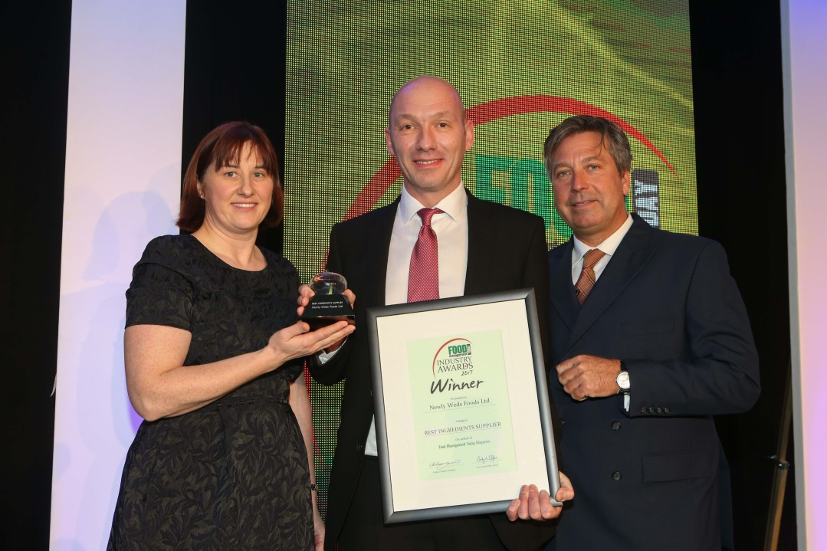

Rob said, “At Newly Weds Foods we find great satisfaction in everything we do and the comprehensive support services we provide to our customers. Our dedicated team of experts are passionate and knowledgeable about food and take pride in delivering next generation products that are not only inspiring new tastes, but are instrumental in helping our customers meet today’s ever more challenging consumer demands.”

-Ends-
For further information, please contact:
Dr Charlotte Baird
Newly Weds Foods Limited
Tel - 01924 280444
www.newlywedsfoods.co.uk
sam@newlywedsfoods.co.uk

